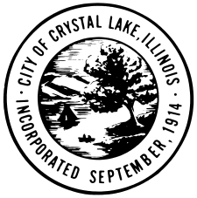

AGENDA

HISTORIC PRESERVATION COMMISSION

**CITY OF CRYSTAL LAKE**

**REGULAR MEETING**

**May 5, 2016**

**Municipal Complex, 100 W. Woodstock Street**

**7:30 PM**

1. Call to Order
2. Roll Call
3. Public Comment
4. Approval of Minutes of the April 7, 2016 Regular Meeting
5. 2016 Trolley Tour

General discussion regarding the tour route, the proposed properties on the tour, the current workload progress, the preparation on the day and other trolley tour discussion.

1. Member Inquiries and Reports
2. Adjournment