The City of Crystal Lake, Illinois

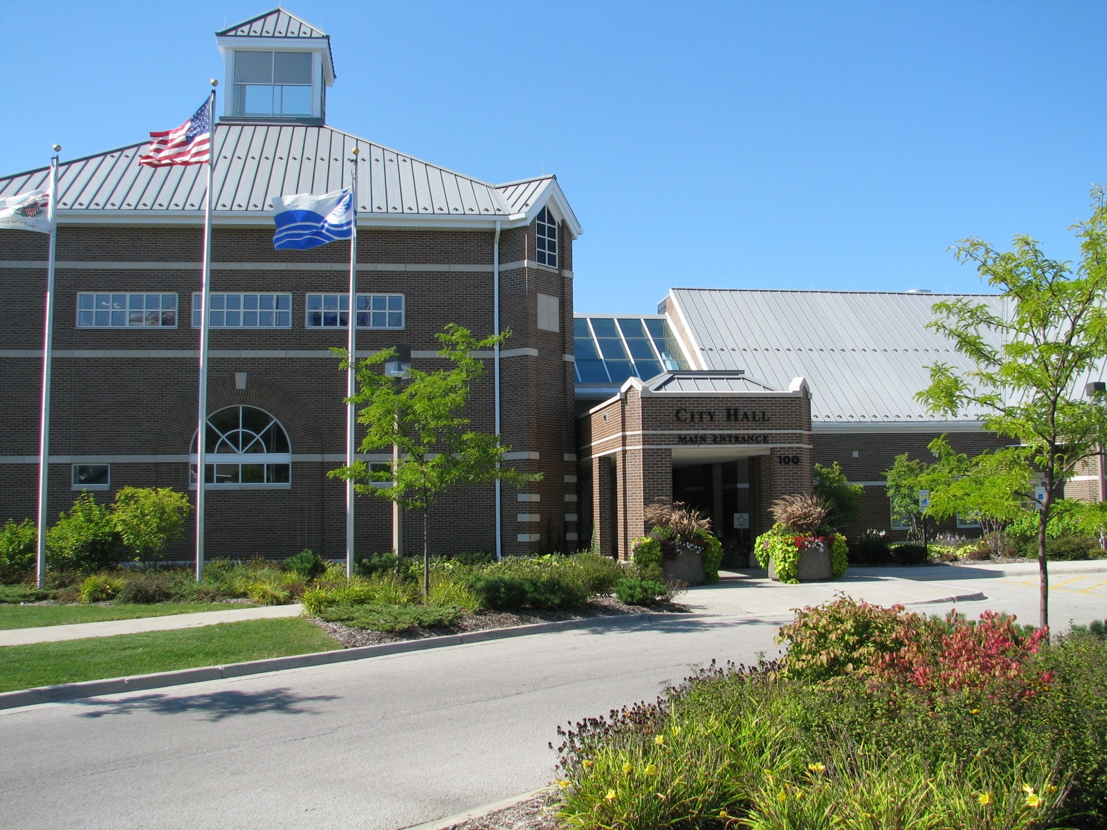

*Invites your interest in the position of*

Director of Public Works

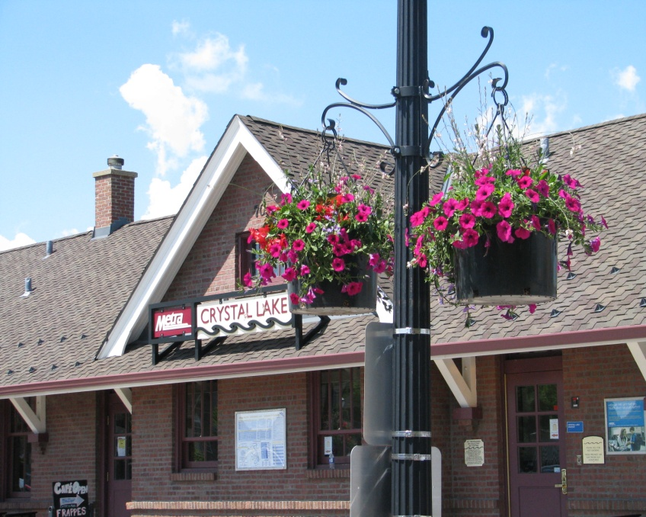

THE POSITION

Under the general direction of the City Manager, the Director of Public Works provides leadership, direction and oversight for the overall operation and activities of the Public Works Department. Department Directors work in an environment that is both politically and financially stable.

CANDIDATE CRITERIA

Minimum Job Requirements Are:

* Bachelor’s Degree in Civil Engineering, Public or Business Administration, or closely related field;
* State of Illinois P.E. registration preferred;
* At least 10 years of related work experience in Public Works Operations with considerable management experience;
* Strong understanding of water, wastewater and sewer systems combined with a comprehensive knowledge of capital infrastructure development; credible communicator with superior writing abilities;
* Thorough understanding of municipal budgeting, alternative service delivery and strategic planning;
* Well-versed in community engagement; will exhibit a passion for providing excellent customer service while maintaining strong connections to the community and respecting the importance of two-way communication with internal and external stakeholders.
* Effective coaching/mentoring skills with relevant team building experience and conflict resolution skills in a union environment with a solid background in performance management; and
* Politically astute with the ability to build productive relationships with the community.

Desirable Attributes Include:

* A **visionary** with the highest integrity, who believes in transparency, promotes high ethical values, and works well with the Mayor/City Council and City Manager, and the community at large;
* An **innovator** who is current on technology and committed to utilizing it to its fullest;
* A **leader** who can effectively allocate resources and is committed to maintain the positive reputation of the soon-to-be APWA accredited Crystal Lake Public Works Department;
* A **professiona**l who demands excellence and will be the positive public face of the Department, is well-respected by the public works staff, and is an effective organizer;
* A **collaborator** with other Department Directors, a mentor for Public Works Department staff and a community problem-solver;
* A **mentor** who is committed to regular training and career development for self and all staff members; and
* A **motivator** who maintains a high-energy atmosphere of team work where work is productive and enjoyable, and provides employees with information, resources, and incentives, as well as a respectful and fair work environment.

**AN EXCEPTIONAL OPPORTUNITY**

This is an exceptional opportunity to provide future vision and guidance to the Public Works Department in the largest community of McHenry County.

Crystal Lake is a city with a rich history, rewarding quality of life and tremendous community spirit. With its high quality retail, residential and service sector development, Crystal Lake has been a major economic engine in Northeastern Illinois for the past decade.

Located 50 miles northwest of Chicago, Crystal Lake residents enjoy the many employment, cultural, and recreational opportunities of a major metropolitan city, yet live in a pleasant, small-town atmosphere.

Originally incorporated as a farming village in 1874, Crystal Lake became a City in 1914 and has retained its charming historical downtown as a reminder of its rural beginnings. While an independent city, Crystal Lake is more suburban in character and is a residence of choice for many who work in the Chicagoland area.

Crystal Lake’s resident population, while primarily Caucasian is diverse, with the population representing minority citizens of African-American, Hispanic, Native American, Asian and Pacific Islander races/cultures. The City’s population in 2010 was 40,743. The City encompasses 18.7 square miles of land with 15,176 households, an average household income of $103,948 and a median home price of $227,300.

CITY OF CRYSTAL LAKE – AN EXCEPTIONAL OPPORTUNITY

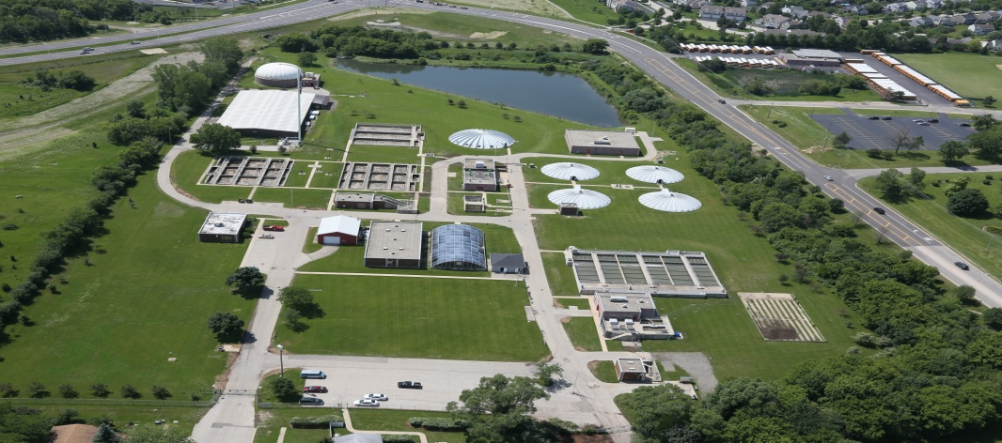

AN EXCEPTIONAL COMMUNITY

The City of Crystal Lake is a politically and financially stable community. In 2010, the City completed a citizen survey through The National Citizen Survey™ (The NCS). Below is a summary of the results of the completed, statistically significant survey.

• The overall quality of life in the City of Crystal Lake was rated as “excellent” or “good” by 89% of respondents.

• 88% reported they plan on staying in the City of Crystal Lake for the next five years.

In 2015, the City was named the 10th *Best Small City in America* by [WalletHub](https://wallethub.com/edu/best-worst-small-cities-to-live-in/16581/), a personal and small business finance advisory group. Rankings for this honor correspond to [twenty-two different criteria](https://wallethub.com/edu/best-worst-small-cities-to-live-in/16581/%20), measuring attributes from the quality of life and cost of living to the number of restaurants per capita. Crystal Lake’s education and health scores topped the scales for school system quality and the availability of medical services.

Also, effective October 1, 2016, Crystal Lake’s ISO rating will be Class 2 and only one of 1,060 fire departments in the nation to achieve this classification. This new designation places Crystal Lake Fire Rescue Department in the top 2.17% of fire departments in the nation for fire suppression services.



JOB DUTIES/RESPONSIBILITIES

* Establishing and maintaining effective working relationships with the Mayor/City Council, City Manager, City Department Directors, business and community groups, other public works organizations, state and federal officials, and representatives of the news media and public;
* Investigating and/or responding to citizens’ questions, concerns and/or complaints relating to the Public Works Department;
* Overseeing the selection, training, performance management, and development of employees in the Public Works Department in accordance with City policy;
* Maintaining fair and consistent treatment of all employees in the Public Works Department and compliance by employees with all City policies and procedures;
* Modeling for staff that all work performed in the Public Works Department meets the City’s high standards for customer service, accuracy, quality, and efficiency;
* Directing activities of the Public Works Department to ensure that appropriate communication and coordination of efforts occur with other departments of the City and all other state and federal agencies;
* Planning and implementing programs effectively so that all operations of the Public Works Department are within authorized resources (i.e., budget, staffing) and effectively managing the budget that is related to his/her organizational responsibilities and within his/her control;
* Developing and implementing strategic and long-range plans for the Public Works Department consistent with the City’s long-range plans;
* Creating methods of ascertaining internal and external customer service quality goals and performance measurement goals;
* Implementing management reporting and control systems and processes to provide for the efficient operation of the Department;
* Dedicating all efforts so that the City’s mission, goals and objectives are fully initiated and supported; and
* Performing other duties and responsibilities as assigned.

CITY OF CRYSTAL LAKE – AN EXCEPTIONAL OPPORTUNITY

CITY GOVERNMENT

The City of Crystal Lake operates under the Council-Manager form of government. Under this plan, the administrative responsibility of the City is centralized in an appointed professional manager. The seven-member legislative body, the City Council, is comprised of the Mayor and six Council Members elected at-large by the Crystal Lake citizenry. The Mayor and City Council are responsible for creating City laws and setting policy direction. Once the Mayor and City Council create a policy or approve a course of action for the City, the City Manager is responsible for executing/implementing the policy.

The City Manager is responsible for overseeing all City departments and has been in his position for thirteen years. The City Manager is also responsible for all employment decisions. City Departments are located at the City of Crystal Lake Municipal Complex.

The City administrative organization is comprised of a number of professionally staffed functional units: *Administration*: City Manager’s Office, Information Technology, Human Resources, and Finance; *Public Works:* Water and Sewer, Wastewater, Fleet and Facility Services, and Streets; *Community Development:* Engineering and Building, and Planning and Economic Development; and *Public Safety:* Fire Rescue and Police. The City has a current annual budget (all funds) of over $96 million, with over 370 full-time, part-time and seasonal personnel. Teamwork and cooperation between departments is highly valued, with all Departments enjoying particularly strong relationships.

The City of Crystal Lake is a regional leader in the areas of planning, growth management, and municipal services. The City offers residents a variety of excellent, high-quality programs and services at one of the lowest municipal tax rates in the area.

LOCAL ECONOMY

Crystal Lake is a well-established, maturing community with an abundance of opportunities for new development as well as redevelopment. The City of Crystal Lake is strongly supportive of business development and the enhancement of quality of life. The community's leaders encourage an entrepreneurial spirit and promote successful partnerships. For these reasons and many more, Crystal Lake is a good place to live and a great place to do business.

Crystal Lake is a short drive away from O'Hare International Airport. The business community benefits from the triangular network of State highways (Routes 14, 31, and 176) and is close to Interstate I-90. The Union Pacific rail line provides easy access to downtown Chicago through the Metra commuter rail service, operated out of two commuter train stations.

Crystal Lake is one of the top 20 Chicagoland communities with over $1 billion in retail sales every year. The City offers superior government services while providing maximum value to our residents and businesses. Combined with our reasonable zoning and permit fees, the cost of doing business in Crystal Lake is kept to a minimum to help businesses remain competitive and profitable.

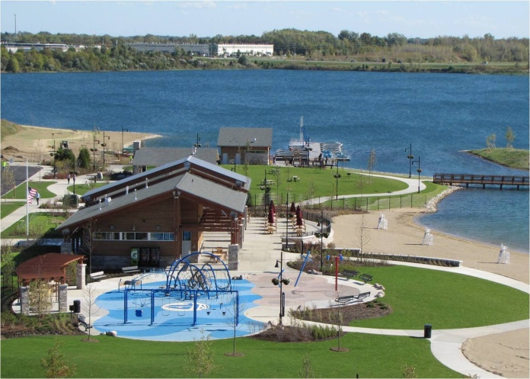

QUALITY OF LIFE

With over one thousand acres of dedicated parks and open space, residents and visitors can enjoy golf, tennis, baseball, football, swimming, cycling, and hiking in well-maintained, accessible areas. The Three Oaks Recreation Area provides swimming, hiking, fishing, boating, and more, in a unique natural environment with pristine clear waters.

Crystal Lake is home to one of the highest-rated elementary and high school districts in the State of Illinois. Students can take advantage of the higher learning opportunities offered by McHenry County College.

Numerous entertainment opportunities exist in Crystal Lake. Live theatrical performances, concerts, and other cultural events are regularly held at the Raue Center for the Performing Arts. Numerous area restaurants allow patrons to enjoy the meal of their choice before or after shows. Shoppers can patronize a variety of stores and service providers that range in size from small independents to large nationally-recognized chains.

CITY OF CRYSTAL LAKE – AN EXCEPTIONAL OPPORTUNITY

PUBLIC WORKS DEPARTMENT

The Director of Public Works, who reports directly to the City Manager, leads a Department of 58 personnel with an annual operating budget of $13 million. The non-supervisory staff is represented by International Union of Operating Engineers Local 150.

This vacancy comes with the retirement of the current Director of Public Works who has 11 years of service with the City of Crystal Lake.

The Department’s Divisions include:

* Administration
* Water & Sewer
  + Eleven wells serve the City’s five water treatment plants.
* Fleet & Facilities
  + Responsible for the maintenance and repair of 350 pieces of equipment, including approximately 155 pieces of rolling stock, in addition to the upkeep of the Municipal Complex.
* Streets
  + Maintains 175 centerline miles of City streets along with routine and special projects for the community.
* Wastewater
  + Maintains two wastewater treatment plants, twenty-seven sanitary lift stations and three storm water lift stations.

The City is currently in the process of $13.88 million in improvements to our wastewater treatment plants to address solids handling, digester capacity, sludge thickening, and other related piping improvements, which require significant upgrades and expansion of existing equipment and facilities.

Now in the preliminary stages of the APWA accreditation process, it is anticipated the Director will support this course of action as the department staff continues to develop and recommend processes for the maintenance and improvement of “best practices” procedures and the delivery of all services.

DEPARTMENT ORGANIZATIONAL CHART

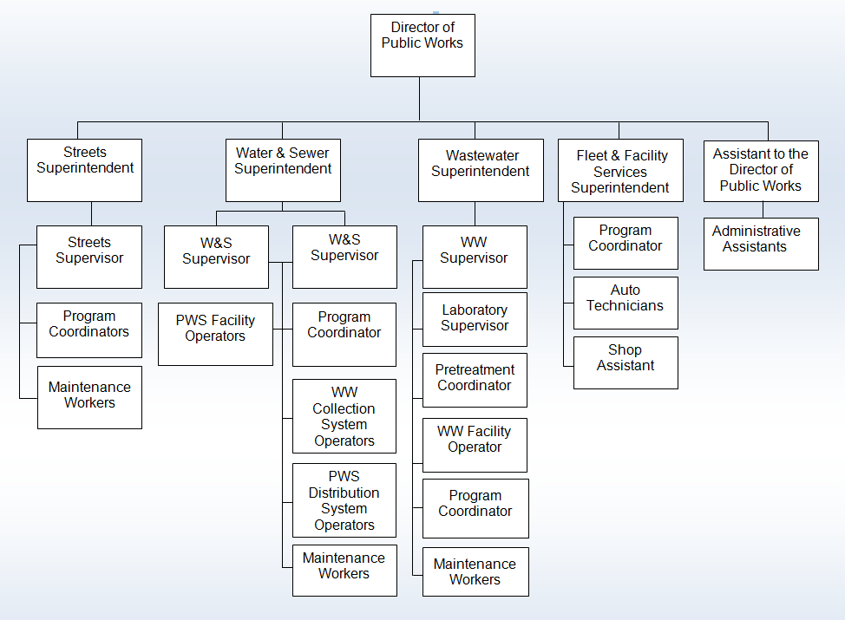

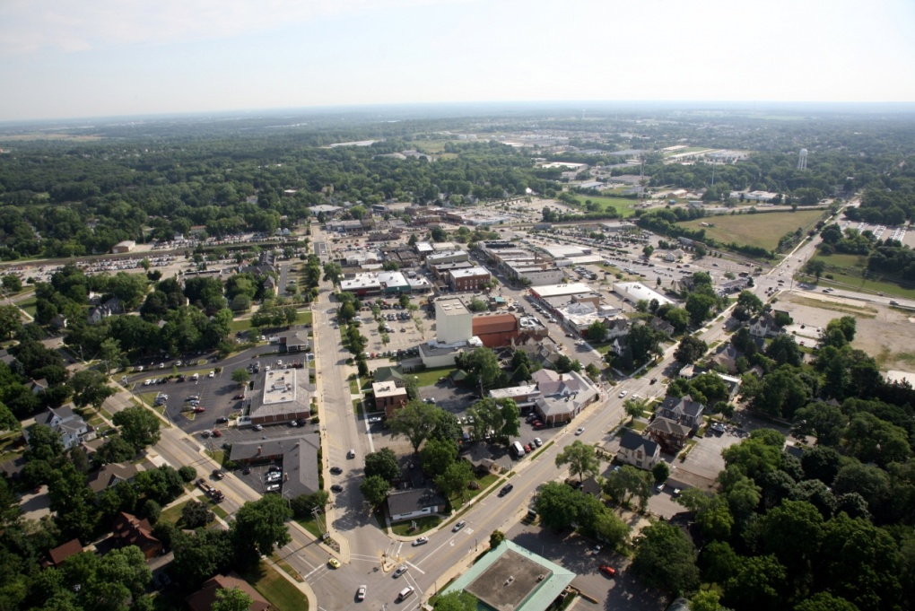

CITY OF CRYSTAL LAKE – AN EXCEPTIONAL OPPORTUNITY

COMPENSATION AND BENEFITS

The Fiscal Year 2016-2017 salary range for this position is $107,730 to $160,488. Salary is commensurate with knowledge, skills and experience.

The City of Crystal Lake provides an excellent fringe benefit package to its full-time employees that includes medical, dental, vision and prescription benefits, life insurance coverage, professional development programs, technology incentives and more.

Please see the Crystal Lake city website at [www.crystallake.org](http://www.crystallake.org) for additional information regarding our community and to learn more about this exciting opportunity.

HOW TO APPLY

Interested individuals should submit an application package, including a letter of interest, resume, salary history, three professional references, and a completed application to Julie Meyer, Director of Human Resources. The employment application and requested attachments can be completed online at [www.crystallake.org](http://www.crystallake.org). The position will remain open until filled.

Finalists will be invited for on-site interviews. A comprehensive reference check and background investigation will be conducted by the City of Crystal Lake on the selected candidate.

For additional information on this exceptional opportunity, please contact:

Julie Meyer, Director of Human Resources

City of Crystal Lake

100 W. Woodstock Street

Crystal Lake, IL 60014

Voice: 815-356-3653 / Fax: 815-356-3690

Email: [jmeyer@crystallake.org](mailto:jmeyer@crystallake.org)

The City of Crystal Lake is an Equal Opportunity Employer. The City of Crystal Lake does not discriminate on the basis of race, color, religion, creed, sex, age, marital status, national origin, sexual orientation, military status, gender identity, or disability in employment or the provision of services.

For additional information on this exceptional opportunity,

please contact Ann Everhart, Director of Human Resources

at 815.356.3653 or [aeverhart@crystallake.org](mailto:aeverhart@crystallake.org)

Completed application packages should be sent to:

Ann Everhart, Director of Human Resources

City of Crystal Lake

100 W. Woodstock Street

Crystal Lake, IL 60014

Voice: 815-356-3653

Fax: 815-356-3690

|  |  |  |
| --- | --- | --- |
| Downtown Flowers Cropped 2  CITY OF CRYSTAL LAKE – AN EXCEPTIONAL OPPORTUNITY | Raue - Winter Cropped |  |

