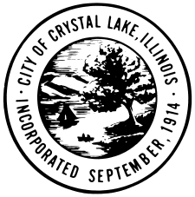

AGENDA

HISTORIC PRESERVATION COMMISSION

**CITY OF CRYSTAL LAKE**

**REGULAR MEETING**

**December 7, 2017**

**City Hall, 100 W. Woodstock Street, Crystal Lake, IL**

**7:30 PM**

1. Call to Order
2. Roll Call
3. Public Comment
4. Approval of Minutes of the October 5, 2017 Regular Meeting
5. 2017-44 Grant Disbursement Approval for 36 N. Virginia - The Alano Club

Approve the disbursement of a $500 grant for restoration work on the windows.

1. 2018 Trolley Tour
2. Member Inquiries and Reports
3. Adjournment