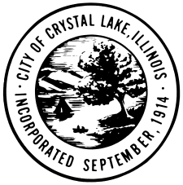

AGENDA

HISTORIC PRESERVATION COMMISSION

**CITY OF CRYSTAL LAKE**

**SPECIAL MEETING**

**100 W. Woodstock Street**

**May 2, 2024**

**3:00 PM**

1. Call to Order
2. Roll Call
3. Public Comment
4. Approval of Minutes of the April 4, 2024 Regular Meeting
5. 135 College Street Certificate of Appropriateness

Vote on the Certificate of Appropriateness for tuck pointing and repairs.

1. Trolley Tour 2024

Discussion on the tour homes, articles and speaking points. Update on costs for book printing, tickets, and advertisements.

1. Other Side Mural

Painting of 135 Beardsley Street. Discussion on painting brick materials.

1. McCormick Park Plaque

Discussion regarding the text for the plaque

1. Member Inquiries and Reports
2. Adjournment